8_ Interpolation
Tasks.

1. Perform linear, quadratic and cubic interpolation using the Lagrange polynomial.

2. Perform interpolation using linear, quadratic, cubic splines.

3. Perform interpolation to determine the value of each function at the points:
- • x= “ variant number” + 0.3
- • x= “ variant number” + 0.7

TABLE OF FUNCTION VALUES No. 1
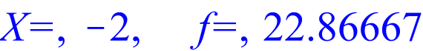
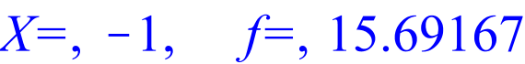
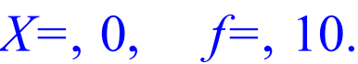
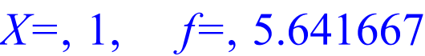
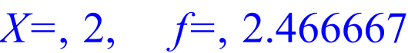
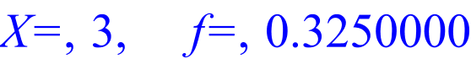
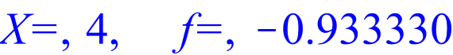
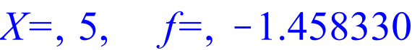
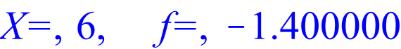
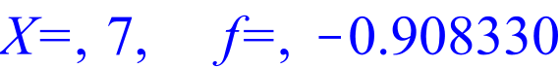
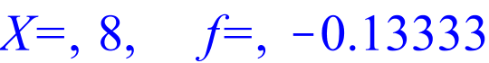
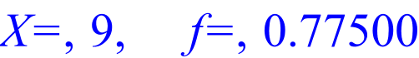
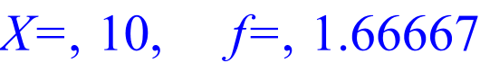
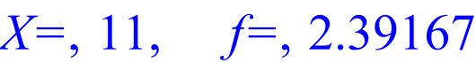
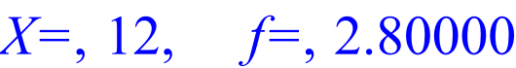
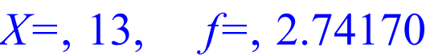
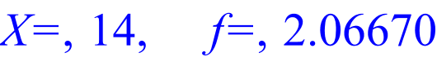
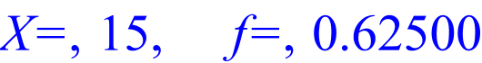
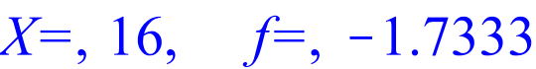
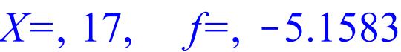
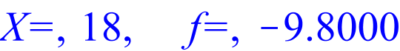
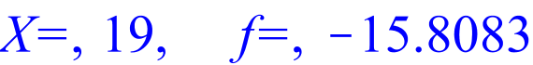
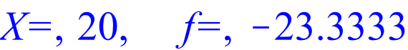
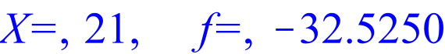
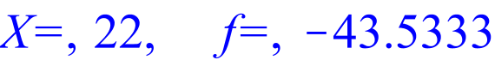
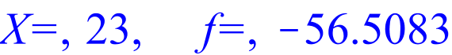
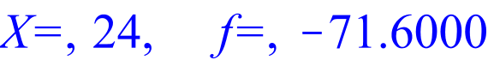
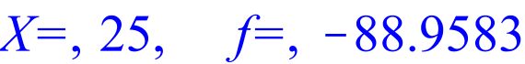
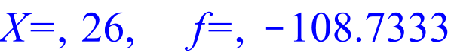
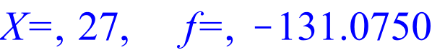
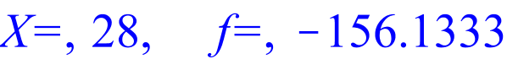
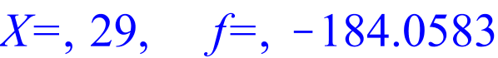
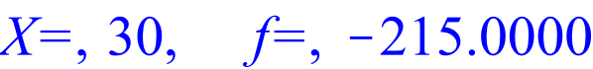

TABLE OF FUNCTION VALUES No. 2
